1. AndroidKeyStore is not used at all:

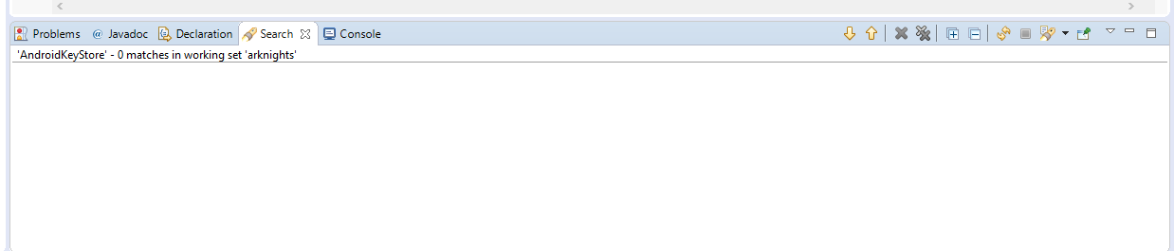

But I managed to find some other classes:

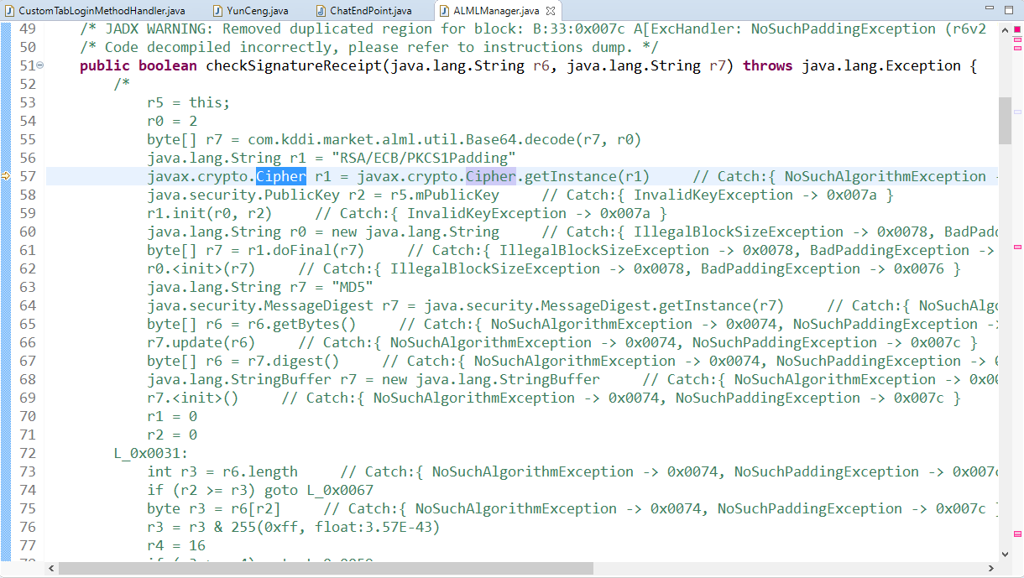

Some public key that is used in signature check is stored in the field of ALMLManager class. Not really safest way to store, but it’s public key. Though I saw usage of kddi sdk in here, so I decided to check it.

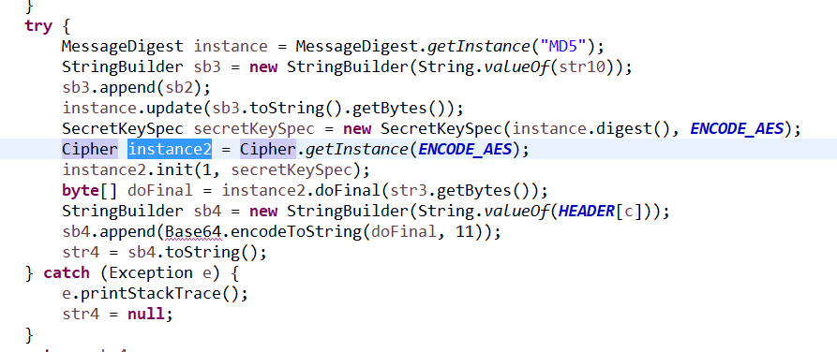

Again Cipher, MessageDigest and SecretKeySpec usage. Not like secret key is stored anywhere afterwards. Also found this.

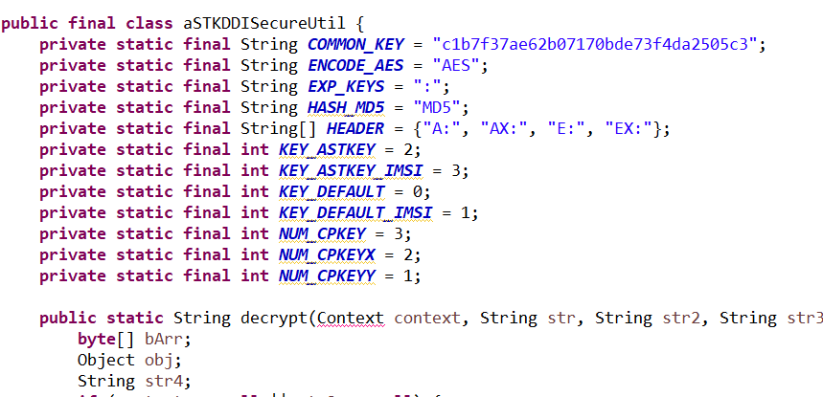

Hey, a key (rooVV)! Not sure what it was really used for when I went through code. But mostly we can see that symmetric keys are not used more than once, they are generated and used in the same place.